Software testing homework

**Problem:** Derive and simplify the path expression for the flow graph in Figure 2.12. Assign reasonable cycle weights and compute the maximum number of paths in the graph and the minimum number of paths to reach all edges.

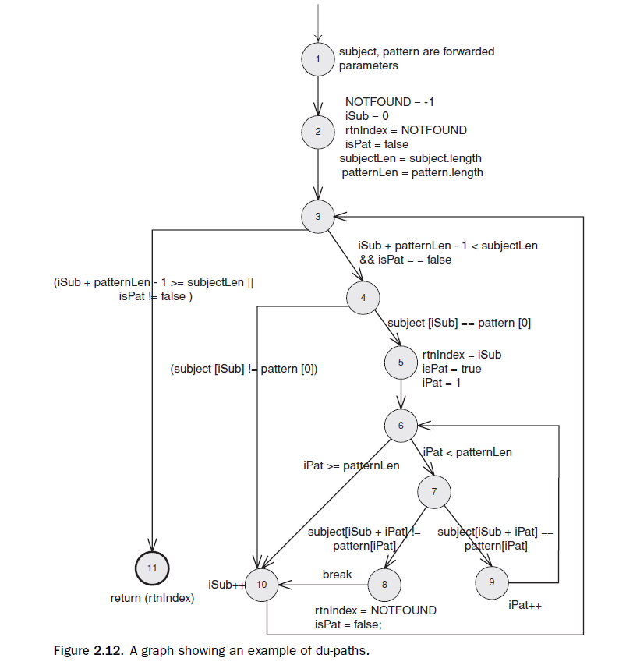

Method:

**Step 1:** First we combine all sequential edges, multiplying the edge labels.

**Step 2:** Next combine all parallel edges, adding the edge labels.

**Step 3:** Remove self-loops (from a node to itself) by creating a new “dummy” node with an incoming edge that uses the exponent operator ‘*’, then merging the three edges with multiplication.

**Step 4:** Now the tester starts choosing nodes to remove. Select a node that is not the initial or final node. Replace it by inserting edges from all predecessors to all successors, multiplying the path expressions from the incoming to the outgoing edges.

**Then loops do the step above**

**Before start**, I make the edge expression as the graph showed below:

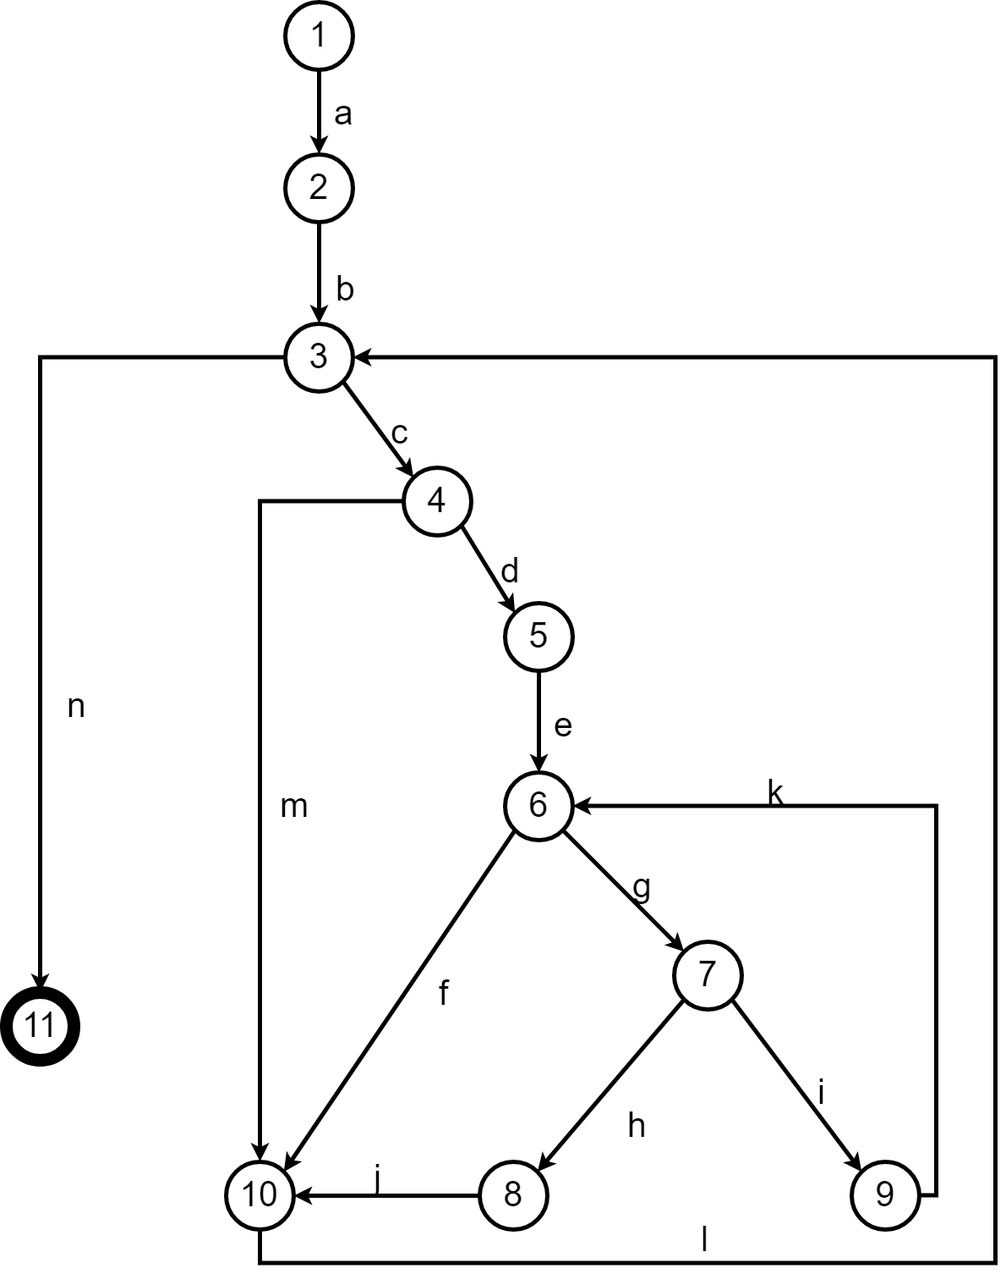

**After combine all sequential edges.**

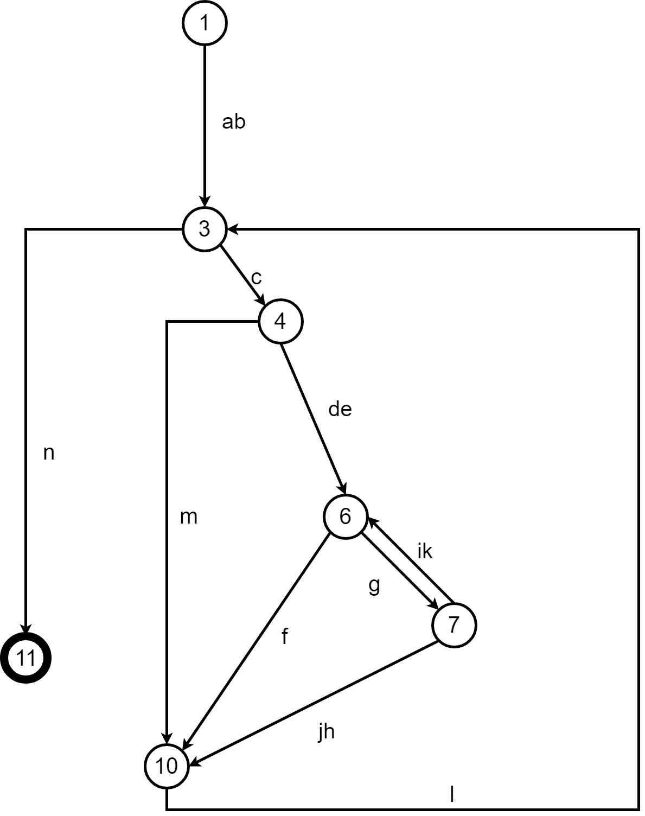

**Remove node 3**

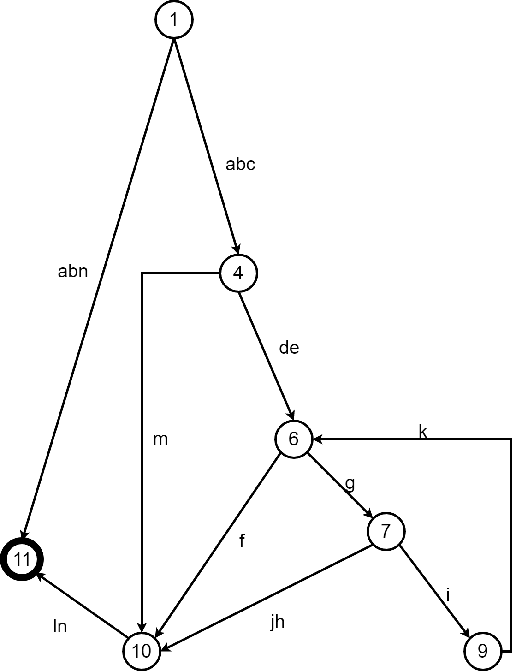

**Remove node 4**

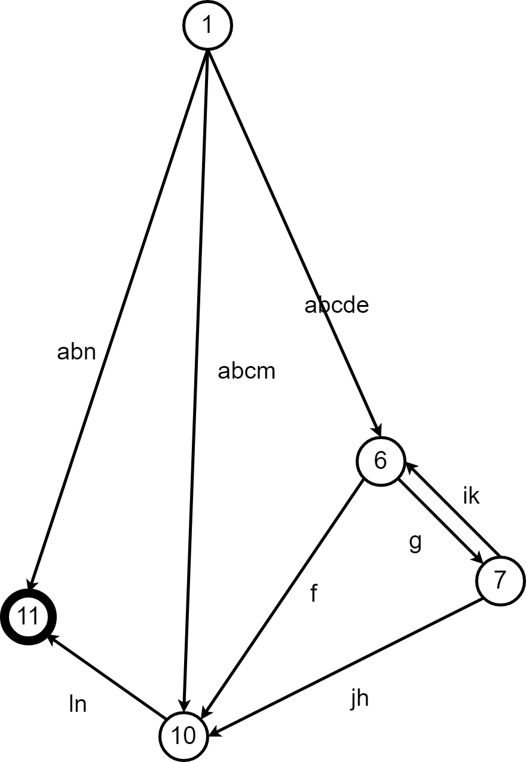

**Remove node 6**

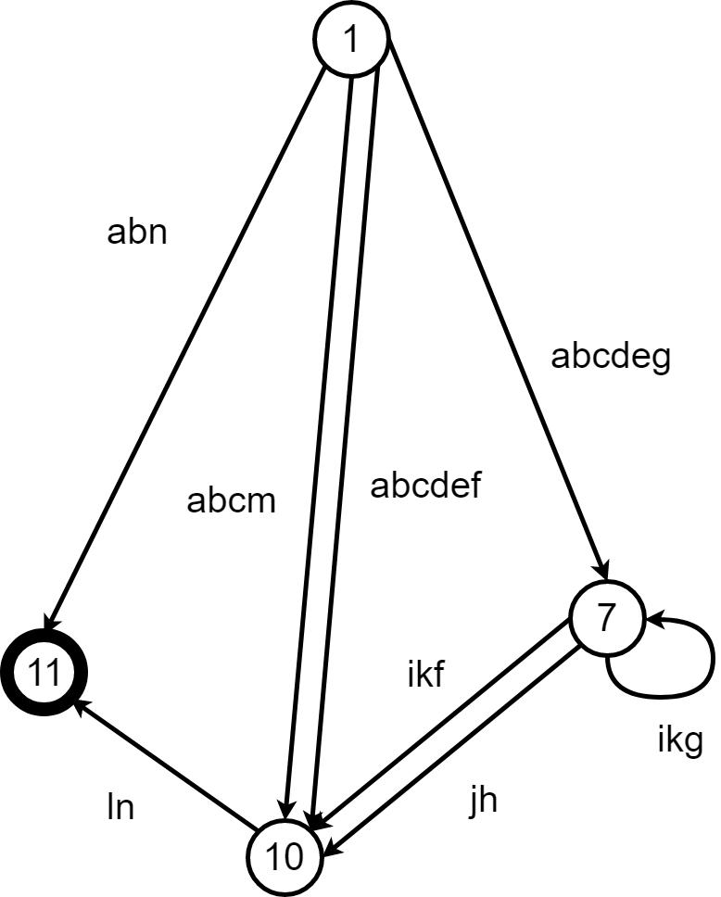

**Combine parallel edge**

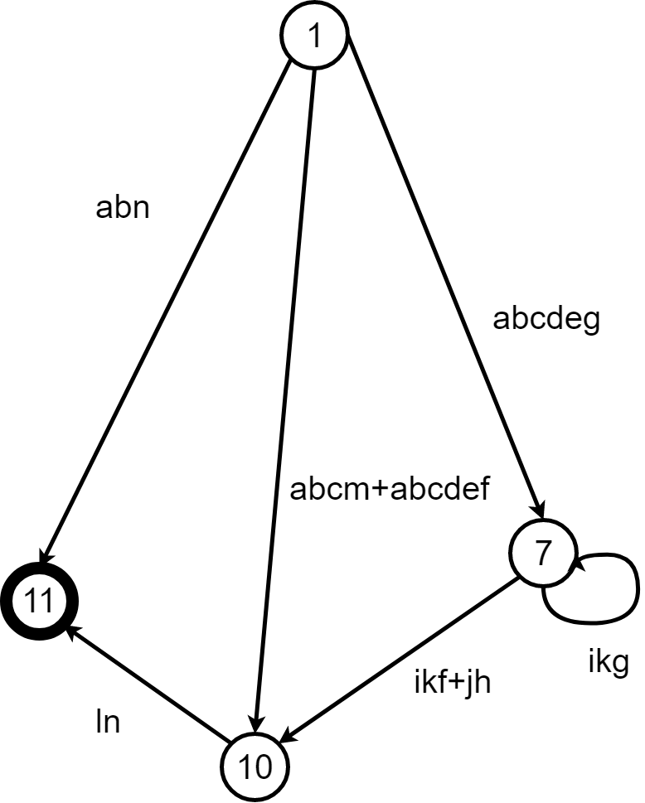

**Remove self-loops (step 1)**

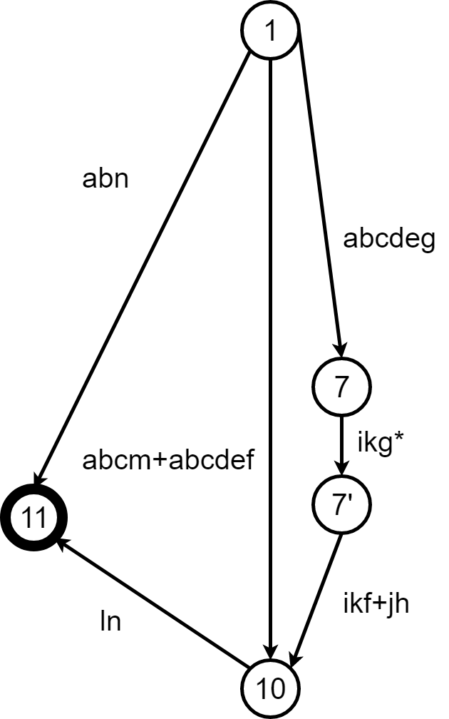

**Remove self-loops (setp 2)**

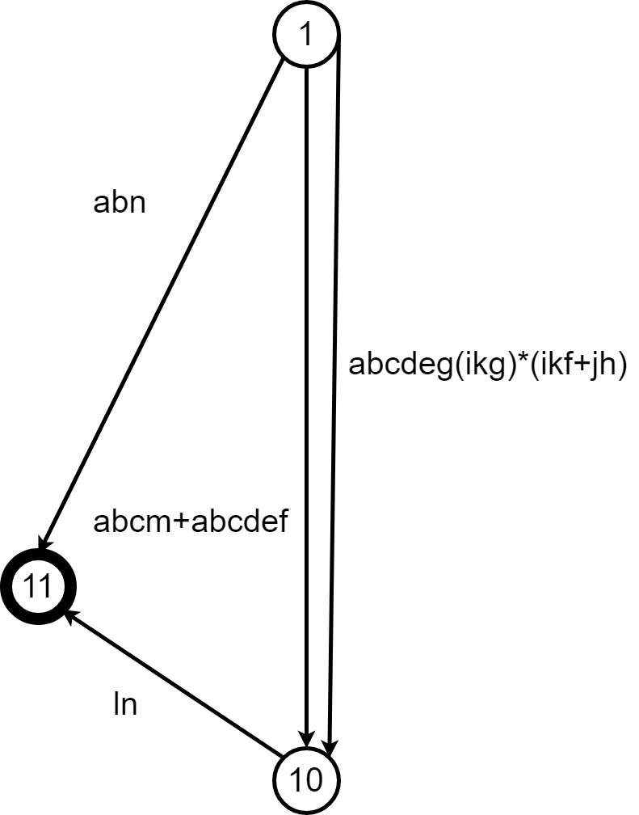

**Combine parallel edges**

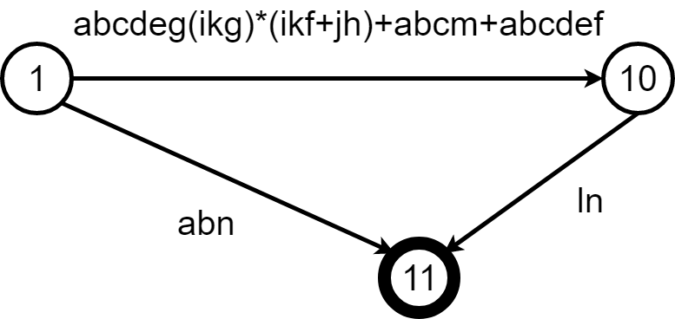

**Combine sequential edges**

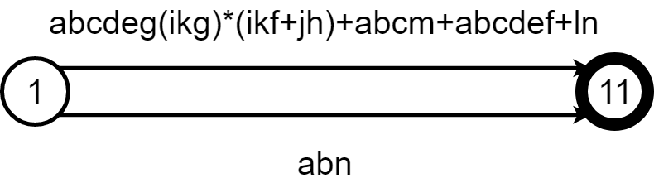

**Combine parallel edges**

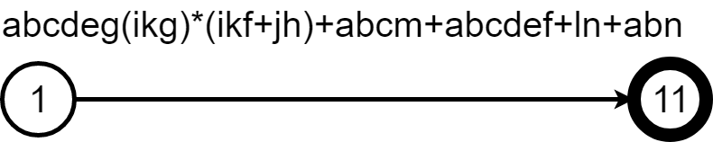

**Then I assign all the edge with weights 1**

**So from the edges algebra:**

**abcdeg(ikg)*(ikf+jh)+abcm+abcdef+ln+abn**

**we get the maximum number of paths:**

**1*1*1*1*1*1*(1*1*1)0-n(1*1*1+1*1)+1*1*1*1+1*1*1*1*1*1+1*1+1*1*1**

**= 1*(*(1+1)+1+1+1+1**

**=2n+4**

**(where n is the times of the loop in the origin graph with edges:i,k,g)**

**Suppose we let n as 2, then the maximum number of paths is 2*2+4 = 8**

**We continue assume that all edges have weight 1**

**So from origin edges algebra expression, we get:**

**1*1*1*1*1*1*(1*1*1)0-n(1*1*1+1*1)+1*1*1*1+1*1*1*1*1*1+1*1+1*1*1**

**=max(1,1,1,1,1,1)*(max(1,1,1))0-n(max(1,1,1)+max(1,1))+**

**max(1,1,1,1)+**

**max(1,1,1,1,1,1)+**

**max(1,1)+**

**max(1,1,1)**

**=1**(1+1)+1+1+1+1**

**=max(1,)*2+4**

**=2\***

**=2n+4**

**So minimum number of paths to reach all edges is 2n+4.**

**Suppose we have n==2 that we have loops that only 2 that can cover all, so that we get the minimum number of paths to reach all edges: that is 8.**